Hardware Interoperability Tests for SATCOM Equipment

Overview
This document describes a set of tests design to demonstrate interoperability between hardware equipment emulating functionality of user terminals, hubs and spacecraft onboard processors. The tests are aimed to any piece of hardware, including prototypes. The devices to be tested should not necessarily include operational software.
The inter-operability tests will be performed against test instruments (signal generator and signal analyzer). A test report and a declaration of interoperability will be given by the manufacturer or the agent performing the tests (Annex A)
The tests are inter-operability tests and not performance tests. Hence, the test parameters indicated below (center frequency, symbol rate, roll-off etc.) are a recommendation. The actual parameters used for a test will be indicated in the test report.
Transmission and reception tests will be performed at IF level.

References
[1] ETSI EN 302 307-1: "Digital Video Broadcasting (DVB); Second generation framing structure, channel coding and modulation systems for Broadcasting, Interactive Services, News Gathering and other broadband satellite applications (DVB-S2)".
[2] ETSI EN 302 307-2: "Digital Video Broadcasting (DVB); Second generation framing structure, channel coding and modulation systems for Broadcasting, Interactive Services, News Gathering and other broadband satellite applications; Part 2: DVB-S2 Extensions (DVB-S2X).
[3] ETSI TS 101 545-1: "Digital Video Broadcasting (DVB); Second Generation DVB Interactive Satellite System (DVB-RCS2); Part 1: Overview and System Level specification".
[4] ETSI EN 301 545-2: "Digital Video Broadcasting (DVB); Second Generation DVB Interactive Satellite System (DVB-RCS2); Part 2: Lower Layers for Satellite standard".

Tests

Applicability
The devices under test (DUT) are user terminals (RCST), gateways (hubs) or on-board processors (regenerative OBP).
For a user terminal the tests will be performed according to the terminal profile (TS 101 545-1 Table 2) and will include:
- Reception of S2, S2X and (if supported) reception of S2X annex E superframes format 5,6 or 7 (bursts).
- Transmission of an RCS2 compliant waveforms as detailed in the latest version of EN 302 454-2, according to Burst Time Plan.
- Doppler compensation capability in both transmit and receive directions (variable Doppler).

For a hub or a regenerative payload OBP, the following tests will be performed:
- Transmission of S2/S2X to multiple terminals, and, if supported, transmission of S2X Annex E superframes (timing according to BHTP).
- Reception of multiple RCS2 signals, according to at least one of the RCS2 supported waveforms.
- Table 1 summarizes the test applicable for each type of device.

Table 1: Applicable Tests
 | RCST | HUB | Regenerative OBP
Reception of continuous S2/S2X Waveforms | X | X | X
Reception of continuous S2/S2X/Annex E Waveforms | X | X | X
Reception of Burst S2/S2X/Annex E | X | X | X
Reception of multiple transmissions S2/S2X/Annex E |  | X | X
Reception of multiple transmissions RCS2 (LM, CPM, LM-SS) |  | X | X
Transmission of RCS2 waveforms (LM, CPM, LM-SS) | X
Transmission of continuous S2/S2X/Annex E Waveforms | X | X | X
Transmission of Burst S2/S2X/Annex E waveforms | X | X | X
Doppler Compensation on Tx | X | X
Doppler Compensation on Rx | X | X

Test Signals
The signals used are generated by a signal generator (for DUT reception tests) or by the DUT (for transmission tests).
The signal types include:
- Continuous S2/S2X waveform
- Continuous S2X Annex E waveforms
- Bursty S2/S2X waveforms
- Bursty S2X Annex E Waveforms.
- RCS2 bursts

Continuous S2/S2X/ waveforms
Continuous S2/S2X waveforms are specified in the main body of [1] and [2].
Optional set of parameters for such a waveform:
- Frequency: not specified
- Filter: SRRC with roll off factor 0.2
- Symbol rate: 20 MS/s
- Mode: S2X CCM – no superframe
- Modcod: QPSK 13/45 normal, pilots = on (PLS=133)

Continuous S2X Annex E waveforms
These waveforms are specified in Annex E [2]. Only superframe formats 5, 6 and 7 (E.3.7, E.3.8, E.3.9) are applicable.
Optional set of parameters for such a waveform:
- Frequency: not specified
- Filter: SRRC with roll off factor 0.2
- Symbol rate: 20 Mspss
- Mode: S2X CCM Annex-E SF6
- Modcod: QPSK 13/45 normal, (PLS=132)
- Payload scrambling sequence= 0
- Reference scrambling sequence =0
- PLI = 0
- Superframe length = 612,540 symbols

Bursty S2/S2X waveforms
Bursty S2/S2X frames are specified in the main body of [1] and [2]. For the tests using bursty transmissions, burst will be composed of at least one frame.
Optional set of parameters for such a waveform:
- Frequency: not specified
- Filter: SRRC with roll off factor 0.2
- Symbol rate: 20 MS/s
- Mode: S2X CCM – no superframe
- Modcod: QPSK 13/45 normal, pilots = on (PLS=133)
- Interval between bursts: 5ms
Figure 1 depicts a typical structure of the waveform, composed of two frames, each with a Physical Layer Header (PLH) and several capacity units (CUs) separated by a 5ms interval.
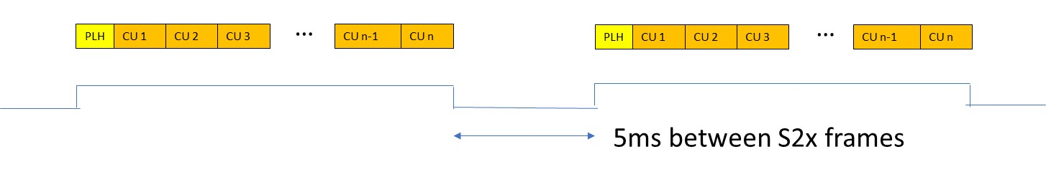
Figure 1: Bursty S2/S2X Waveform Structure

Bursty S2X Annex E waveforms
These waveforms are specified in Annex E of [2]. Only superframe formats 5, 6 and 7 (E.3.7, E.3.8, E.3.9) are applicable.
Optional set of parameters for such a waveform:
- Frequency: not specified
- Filter: SRRC with roll off factor 0.2
- Symbol rate: 20 MS/ss
- Mode: S2X CCM Annex-E SF6
- Modcod: QPSK 13/45 normal, (PLS=132)
- Payload scrambling sequence= 0
- Reference scrambling sequence =0
- PLI = 0
- Superframe length = 10 frames
- Interval between frames: 30ms
Figure 2 (a) depicts the structure of a superframe, composed of a Superframe Header (SFH), Physical Layer (S2/S2X) frames (PLF) and a Postamble (PACS), issued at the end of a superframe just before the dwell extinction Dummy symbols can be sent after the postamble.
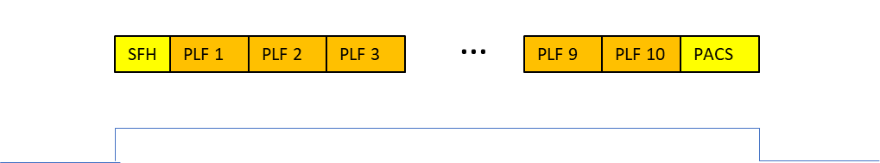
Figure 2 (a): Typical Superframe Structure
Figures 2 (b)- (d) show possible configuration of the entire waveform, composed of several superframes. The interval between superframes (dwells) is a capacity of the design. Thus, the minimal interval between dwells is a result, not a requirement. The interval between dwells can be filled with dummies, no power or noise, as described in the figure.

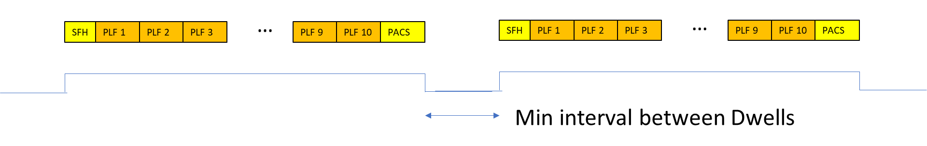
Figure 2 (b): Typical Waveform Structure: Several superframes (dwells) no transmission power in the interval.

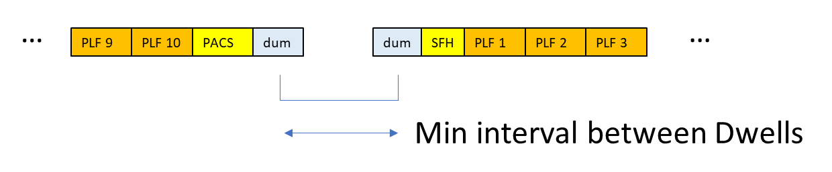
Figure 2 (c): Typical Waveform Structure: Several superframes (dwells) interval filled with dummy symbols

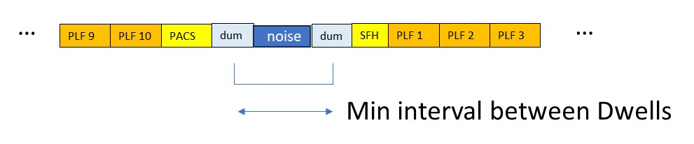
Figure 2 (d): Typical Waveform Structure: Several superframes (dwells) interval filled with noise

RCS2 Waveforms
These waveforms are specified in [4]
Optional set of parameters for such a waveform:
- Separation: 10 MHz
- Center frequency: not specified
- Filter: RRC with roll off factor 0.2
- Symbol rate: 10Msps
- Waveform id for both: 1 (Linear Modulation)
- Content type: Logon
- Signal length: 1 burst
- Burst rate: 100 Hz

Signal Generation and Analysis
For reception tests, the signals can be generated by signal generators which support S2X and RCS2 standards (see Appendix B), or by using the symbol streams ((I/Q PLFRAMES) available in the DVB V&V website (https://dvb.org/specifications/verification-validation/dvb-s2x-beam-hopping-formats-verification-validation/) , applying up-sampling, pulse shaping with the appropriate roll-off factor, and upconverting to the test IF frequency.
Any compliant S2, S2X or RCS2 transmitter can be used as well.
Figure 3 shows an example of a setup of R&S®SMW200A signal generator:
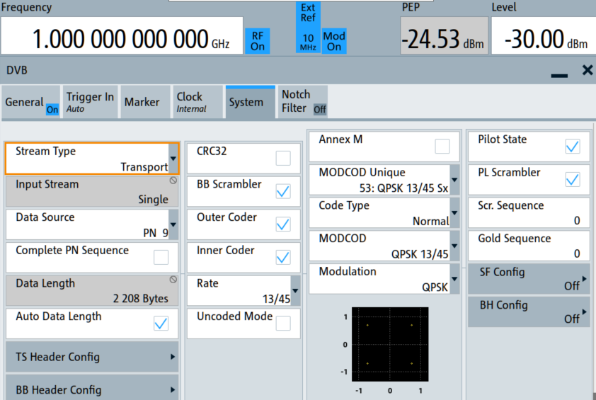
Figure 3: SMW200A Signal generator setup
Signal analyzers used for transmission tests need to have the following capabilities:
- Spectrum analysis to measure spectrum mask
- Matched filtering according to S2X and RCS2 waveforms (SRRC, CPM)
- Symbol synchronization and EVM/MER measurement.
- Symbol decoding and header pattern matching.
Figure 4 shows screen shots of R&S FSW showing the spectrum and a signal analysis screen showing the constellation, EVM and a detection of the preamble symbols.
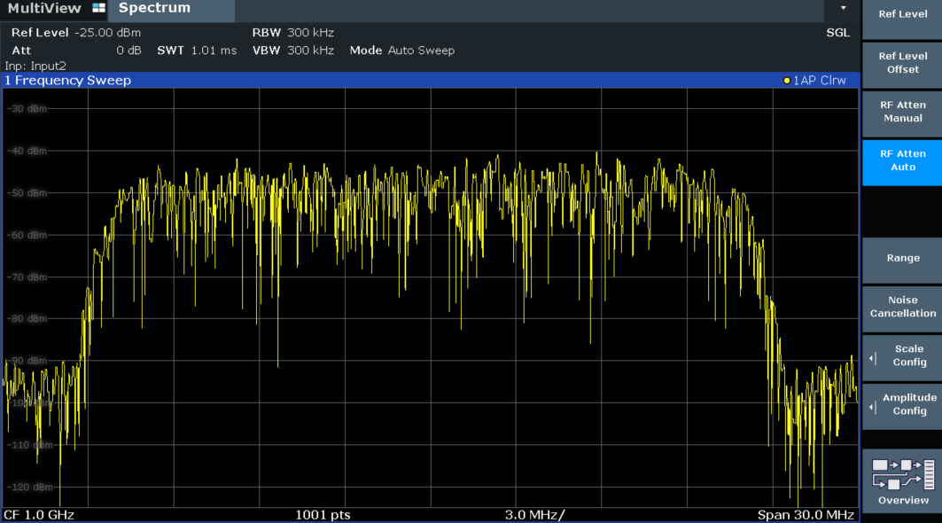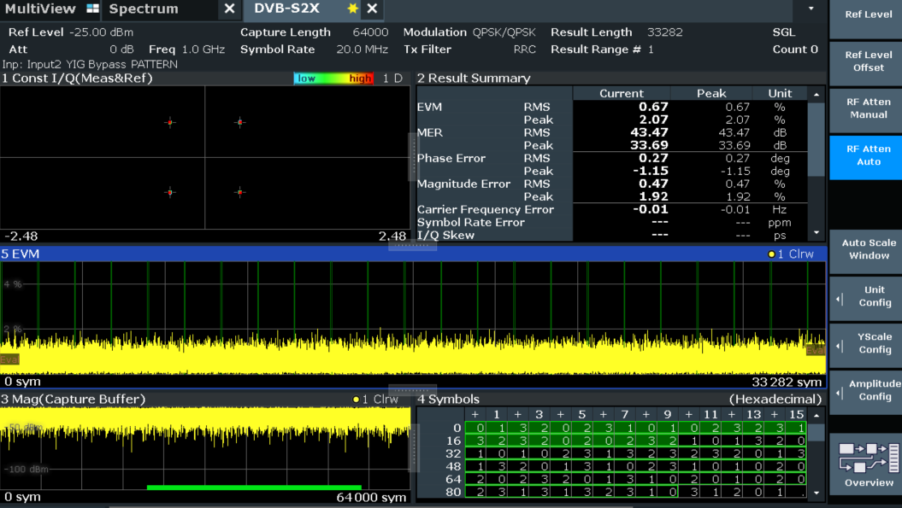
- Signal Spectrum (b) Analysis Screen

Figure 4: R&S FSW Signal Analyzer Screen shots
See Appendix B for a list of test instruments that have those features.

Test Setups
These setups represent the standard setup for the reception and the transmission test. Test specific modifications to those setups can apply.

Reception Test
The general reception test consists of a signal generator, like a R&S®SMW200A, that is connected with a cable or over the air to a receiver that is the Device Under Test (DUT).
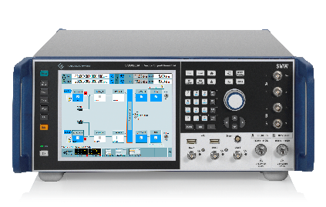
DUT
Figure 5: Reception test setup

1. Connect the DUT to the signal generator
2. Configure the waveform according to the test description
3. Verify the right reception of the signal at the DUT

Transmission Test
The general transmission test consists of a signal analyzer, like a R&S FSW, that is connected with a cable or over the air to a transmitter that is the DUT.
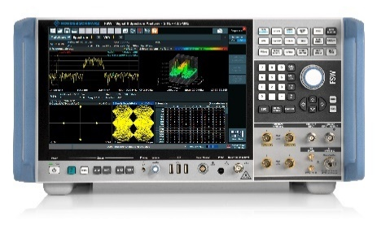
DUT

Figure 6: Transmission test setup

1. Connect the DUT to the signal analyzer
2. Configure the waveform according to the test description
3. Verify the KPI’s of the specific test with the signal analyzer

Tests Description

Reception of continuous S2/S2X/ waveforms
- Test instrument: Signal generator
- Transmitted signal: Continuous S2X waveform
- Test criterion: Decoding of the PLH (as reported by the DUT)

Reception of continuous S2/S2X/Annex E waveforms
- Test instrument: Signal generator
- Transmitted signal: Continuous S2X waveform
- Test criterion: Decoding of the PLH/SFH (as reported by the DUT)

Reception of bursty S2/S2X/Annex E waveform
- Test Instrument: Signal Generator
- Transmitted signal: S2X waveform bursts transmitted with some rate
- Test Criterion: Decoding of the PLH/SFH (as reported by the DUT)

Reception of multiple transmissions RCS2 (LM, CPM, LM-SS)
- Test Instrument: Signal Generator – multiple channels
- Transmitted signal: RCS2 waveform bursts transmitted with some rate over two or more adjacent carriers
- Test Criterion: Identification of the RCS2 preambles
- Test Signal parameters:
- Number of transmissions: 2
- Separation: 10 MHz

Reception of multiple transmissions S2/S2X/Annex E
- Test Instrument: Signal Generator with multiple channels
- Transmitted signal: Bursty S2X waveform and/or bursty S2X Annex E waveforms transmitted with some rate over two or more adjacent carriers.
- Test criterion: Decoding of the PLH/SFH
- Test Signal parameters:
- Number of transmission: 2
- Separation: 20 MHz
- Interval between bursts 10msec

Transmission of continuous S2/S2X/Annex E waveforms
- Test Instrument: Signal Analyzer
- Transmitted signal: S2X waveform CCM mode
- Test criterion: Spectrum mask, EVM, PLH identification by the signal analyzer

Transmission of RCS2 Waveforms (LM, LM-SS, CPM)
- Test Instrument: Signal Analyzer (scope)
- Transmitted signal: RCS2 bursts transmitted at some rate
- Test criterion: Spectrum mask, EVM, preamble/postamble identification by the signal analyzer, burst rate verified.

Transmission of burst S2/S2X/ Annex E waveform
- Test Instrument: Signal Analyzer (scope)
- Transmitted signal: S2X bursts transmitted at some rate
- Test criterion: Spectrum mask, EVM, PLH/SFH identification by the signal analyzer, burst rate verified.

Doppler Compensation on Tx
- Test Instrument: Signal Analyzer, frequency shift set-up
- Transmitted signal: Any
- Test procedure: Configure the DUT modulator to apply a known frequency shift (fixed?) to the transmitted signal.
- Test criterion: signal at the analyzer is centered within the designated bandwidth, and shifted in frequency.

Doppler Compensation on Rx
- Test Instrument: Signal generator.
- Transmitted signal: Any
- Test procedure: Apply a known frequency shift (fixed?) to the transmitted signal.
- Configure the DUT demode to apply the inverse of the shift.
- Test criterion: maximum value of received SNR compared to the DUT without compensation.

Annex A
Interoperability Declaration
DUT
Mfr. ______
Model: _____________
Type __________ (RCST/GW/OBP) RCST Profile: ______
Tests Performed:
Reception of continuous S2/S2X Waveforms
Reception of continuous S2/S2X/Annex E Waveforms
Reception of Burst S2/S2X/Annex E
Reception of multiple transmissions S2/S2X/Annex E
Reception of multiple transmissions RCS2 (LM, CPM, LM-SS)
Transmission of RCS2 waveforms (LM, CPM, LM-SS)
Transmission of continuous S2/S2X/Annex E Waveforms
Transmission of Burst S2/S2X/Annex E waveforms
Doppler Compensation on Tx
Doppler Compensation on Rx

For each test:
Test Name:
Test instrument:
Test Signal(s):
Parameters:

Annex B
List of Test Instruments
Signal generators
R&S SMW200A
Features supported:
- Generation of S2/S2X continuous waveform
- Generation of S2/S2X bursts
- Generation of Annex E superfrmaes
- Generation of Annex E Bursts
- Generation of RCS2 Linear Modulation Bursts
- Generation of an Arbitrary waveform
- Centre frequency shift according to a given profile
R&S FSW
- Spectrum analysis to measure spectrum mask
- Matched filtering according to S2X and RCS2 waveforms (SRRC, CPM)
- Symbol synchronization and EVM/MER measurement.
- Symbol decoding and header pattern matching.

